2021 Fundraiser Auction Credit:

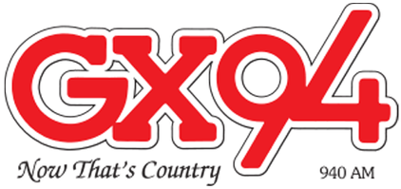
This Photo by Unknown Author is licensed under CC BY-SA

$500.00 Advertising Credit

Per: Colin Laird
1831 Smith Street
Yorkton, SK S3N 3V3
1-306-782-2256
claird@harvardmedia.com 1/1

